Lab 1: Build an Agent with wx.ai Agent Lab

In this lab, you will build a Supplier Researcher Agent using Watsonx.ai Agent Lab. This agent will allow you to research the suppliers for procuring Xtralife based on past supplier performance, procurement rules and customer reviews.

Files used in lab can be downloaded from box:
<Link to download to be changed>

Steps to Create the Agent

Step 1: Create a Project
- If this is your first time using this account, you must create a project before using Agent Lab.

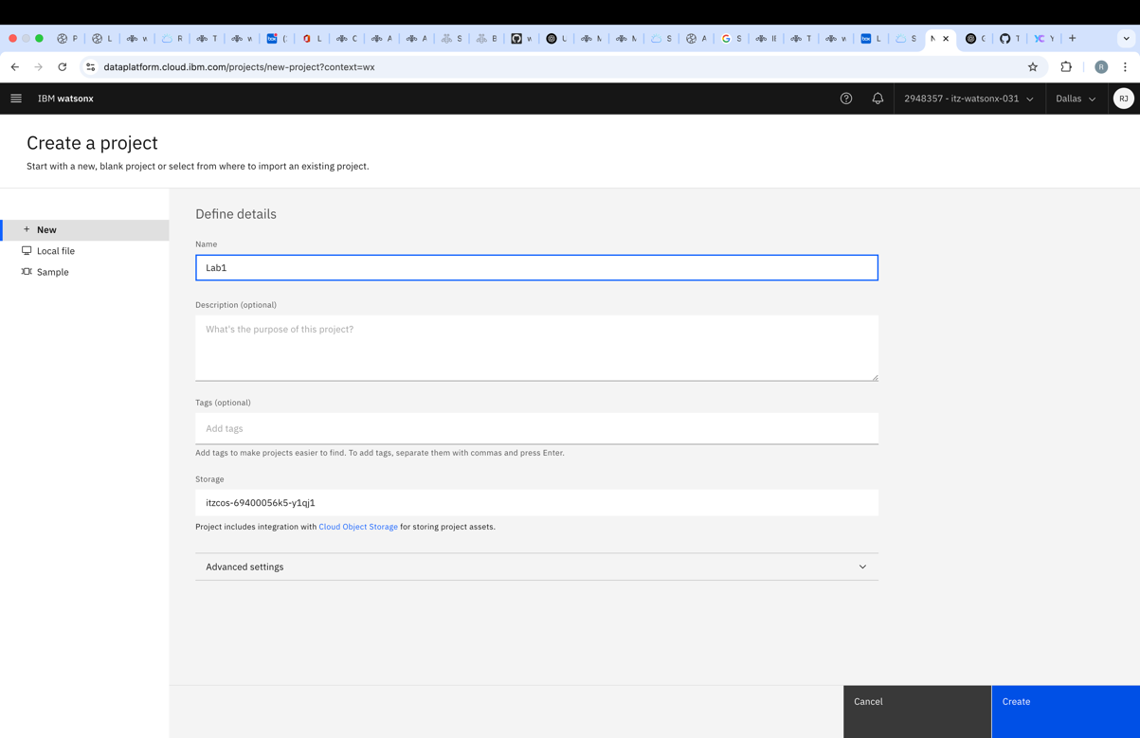

Step 2: Associate the Watsonx.ai Service
- After creating the project, navigate to Manage → Services & Integrations → Associate Service.
- Select Watsonx.ai and associate it with your project.

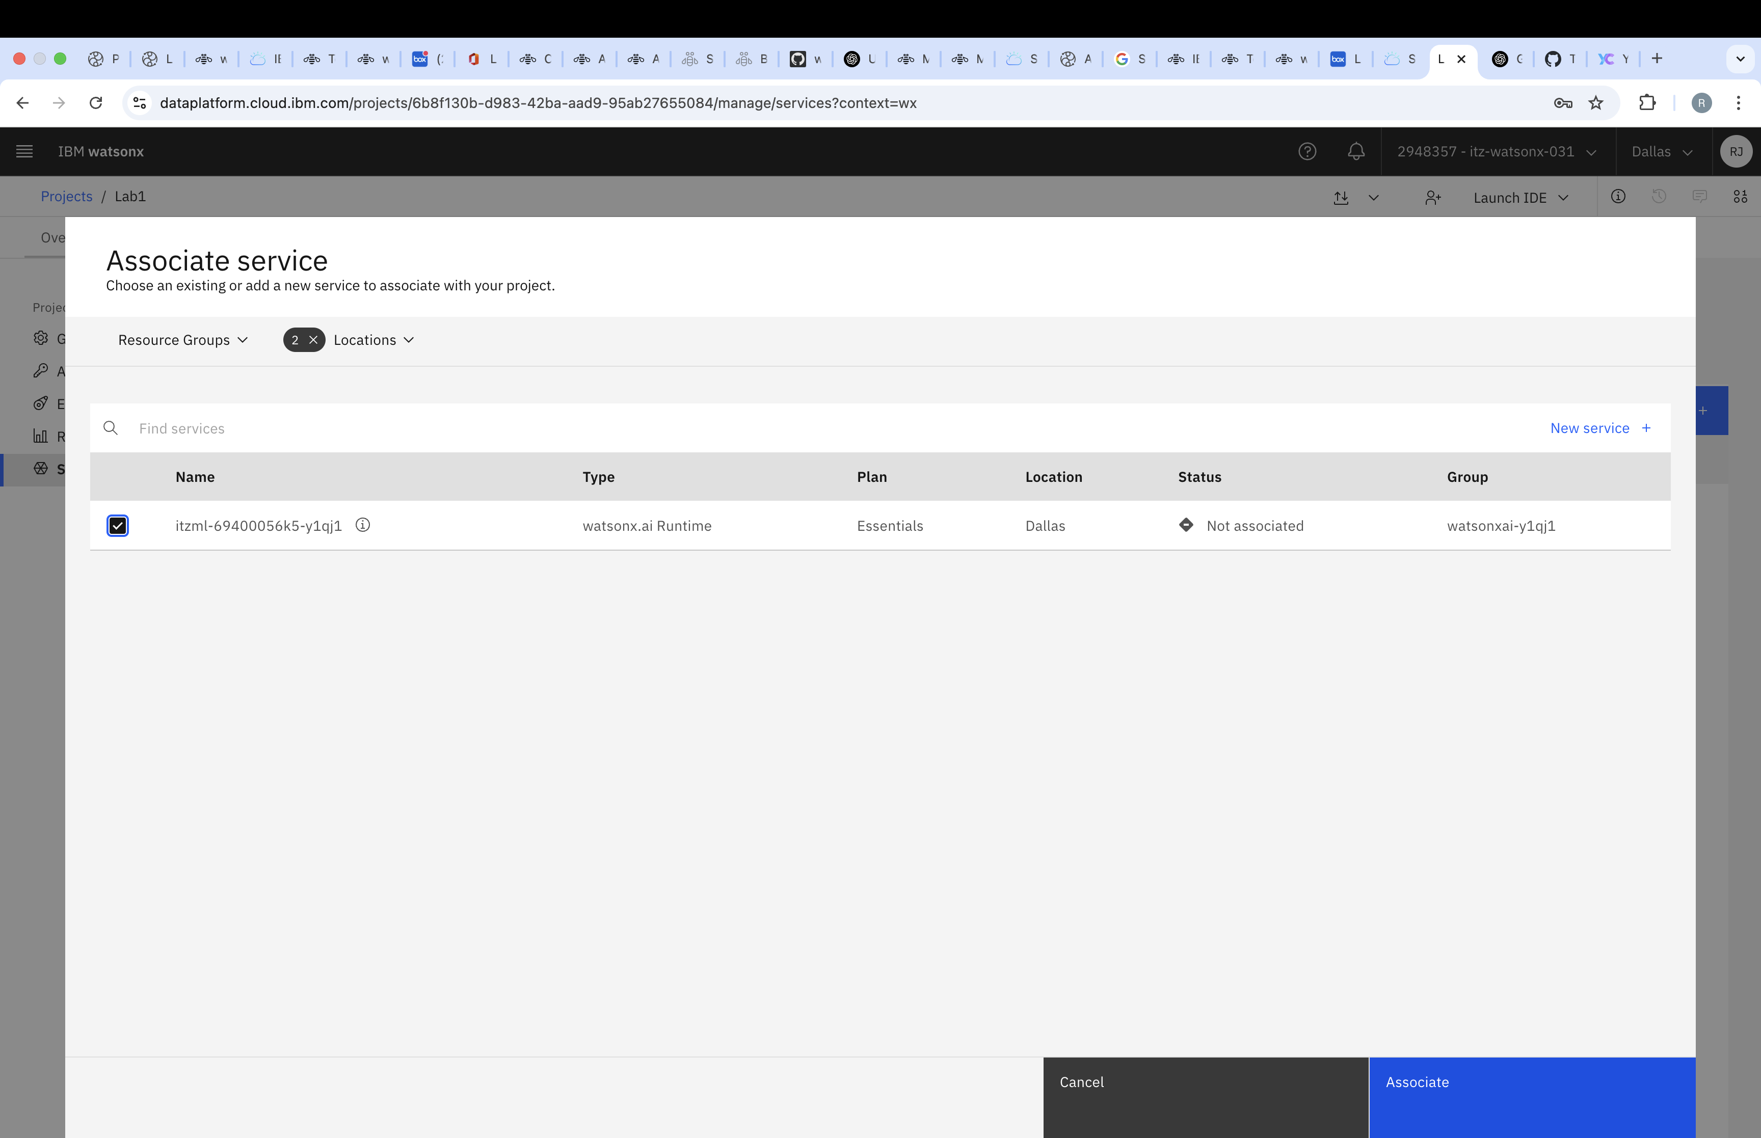

Step 3: Add a New Asset
- Go to the Assets tab and click New Asset.

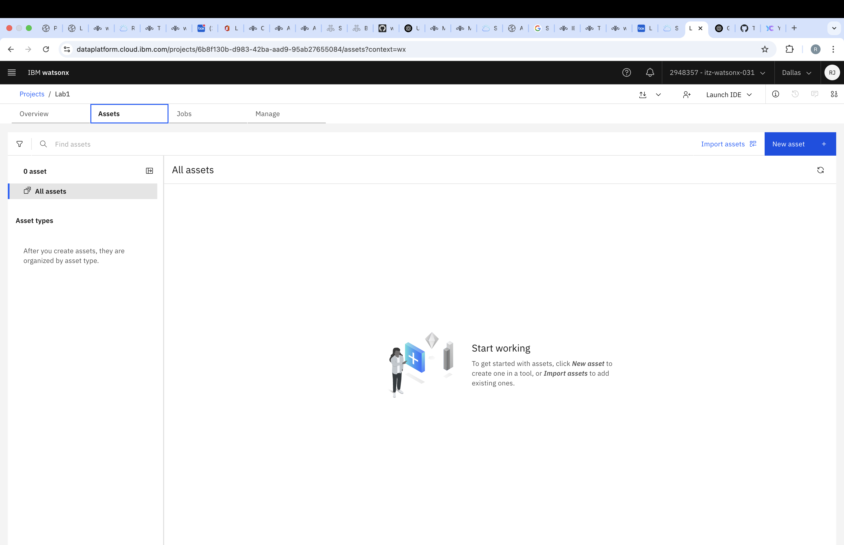

Step 4: Create an In-Memory Vector Store
- Search for "Ground Gen AI with Vectorized Documents" and click to create an In-Memory Vector Store.

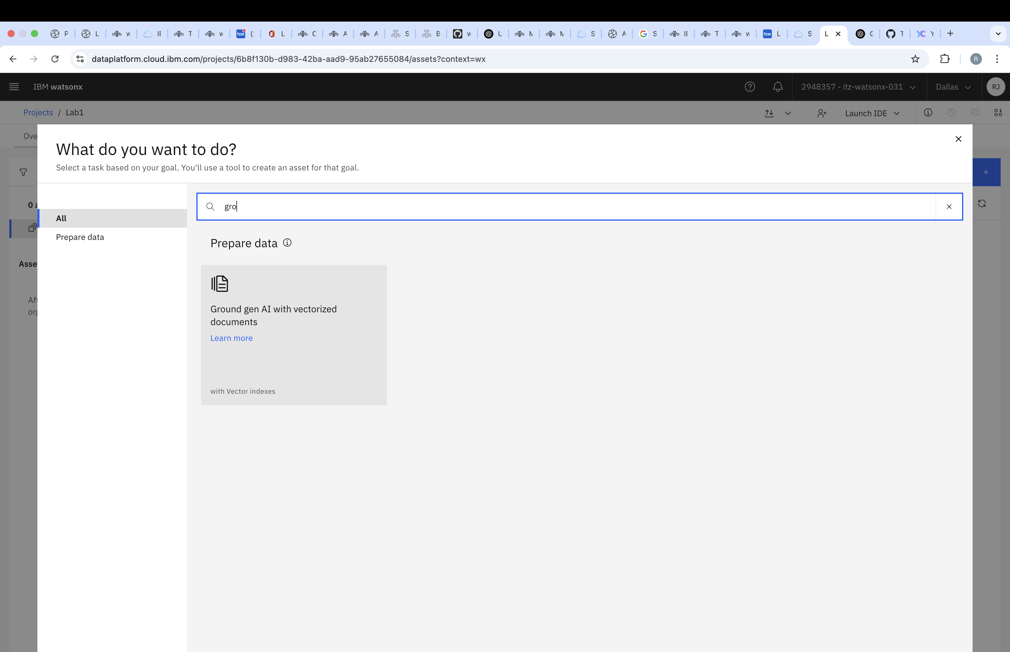

Step 5: Choose the Vector Index Type
- Click on Ground Gen AI with Vectorized Documents.
- You will see three options to create a vector index:
  - In-Memory
  - Watsonx.data (Milvus)
  - Elasticsearch (ES)
- For this lab, select In-Memory.
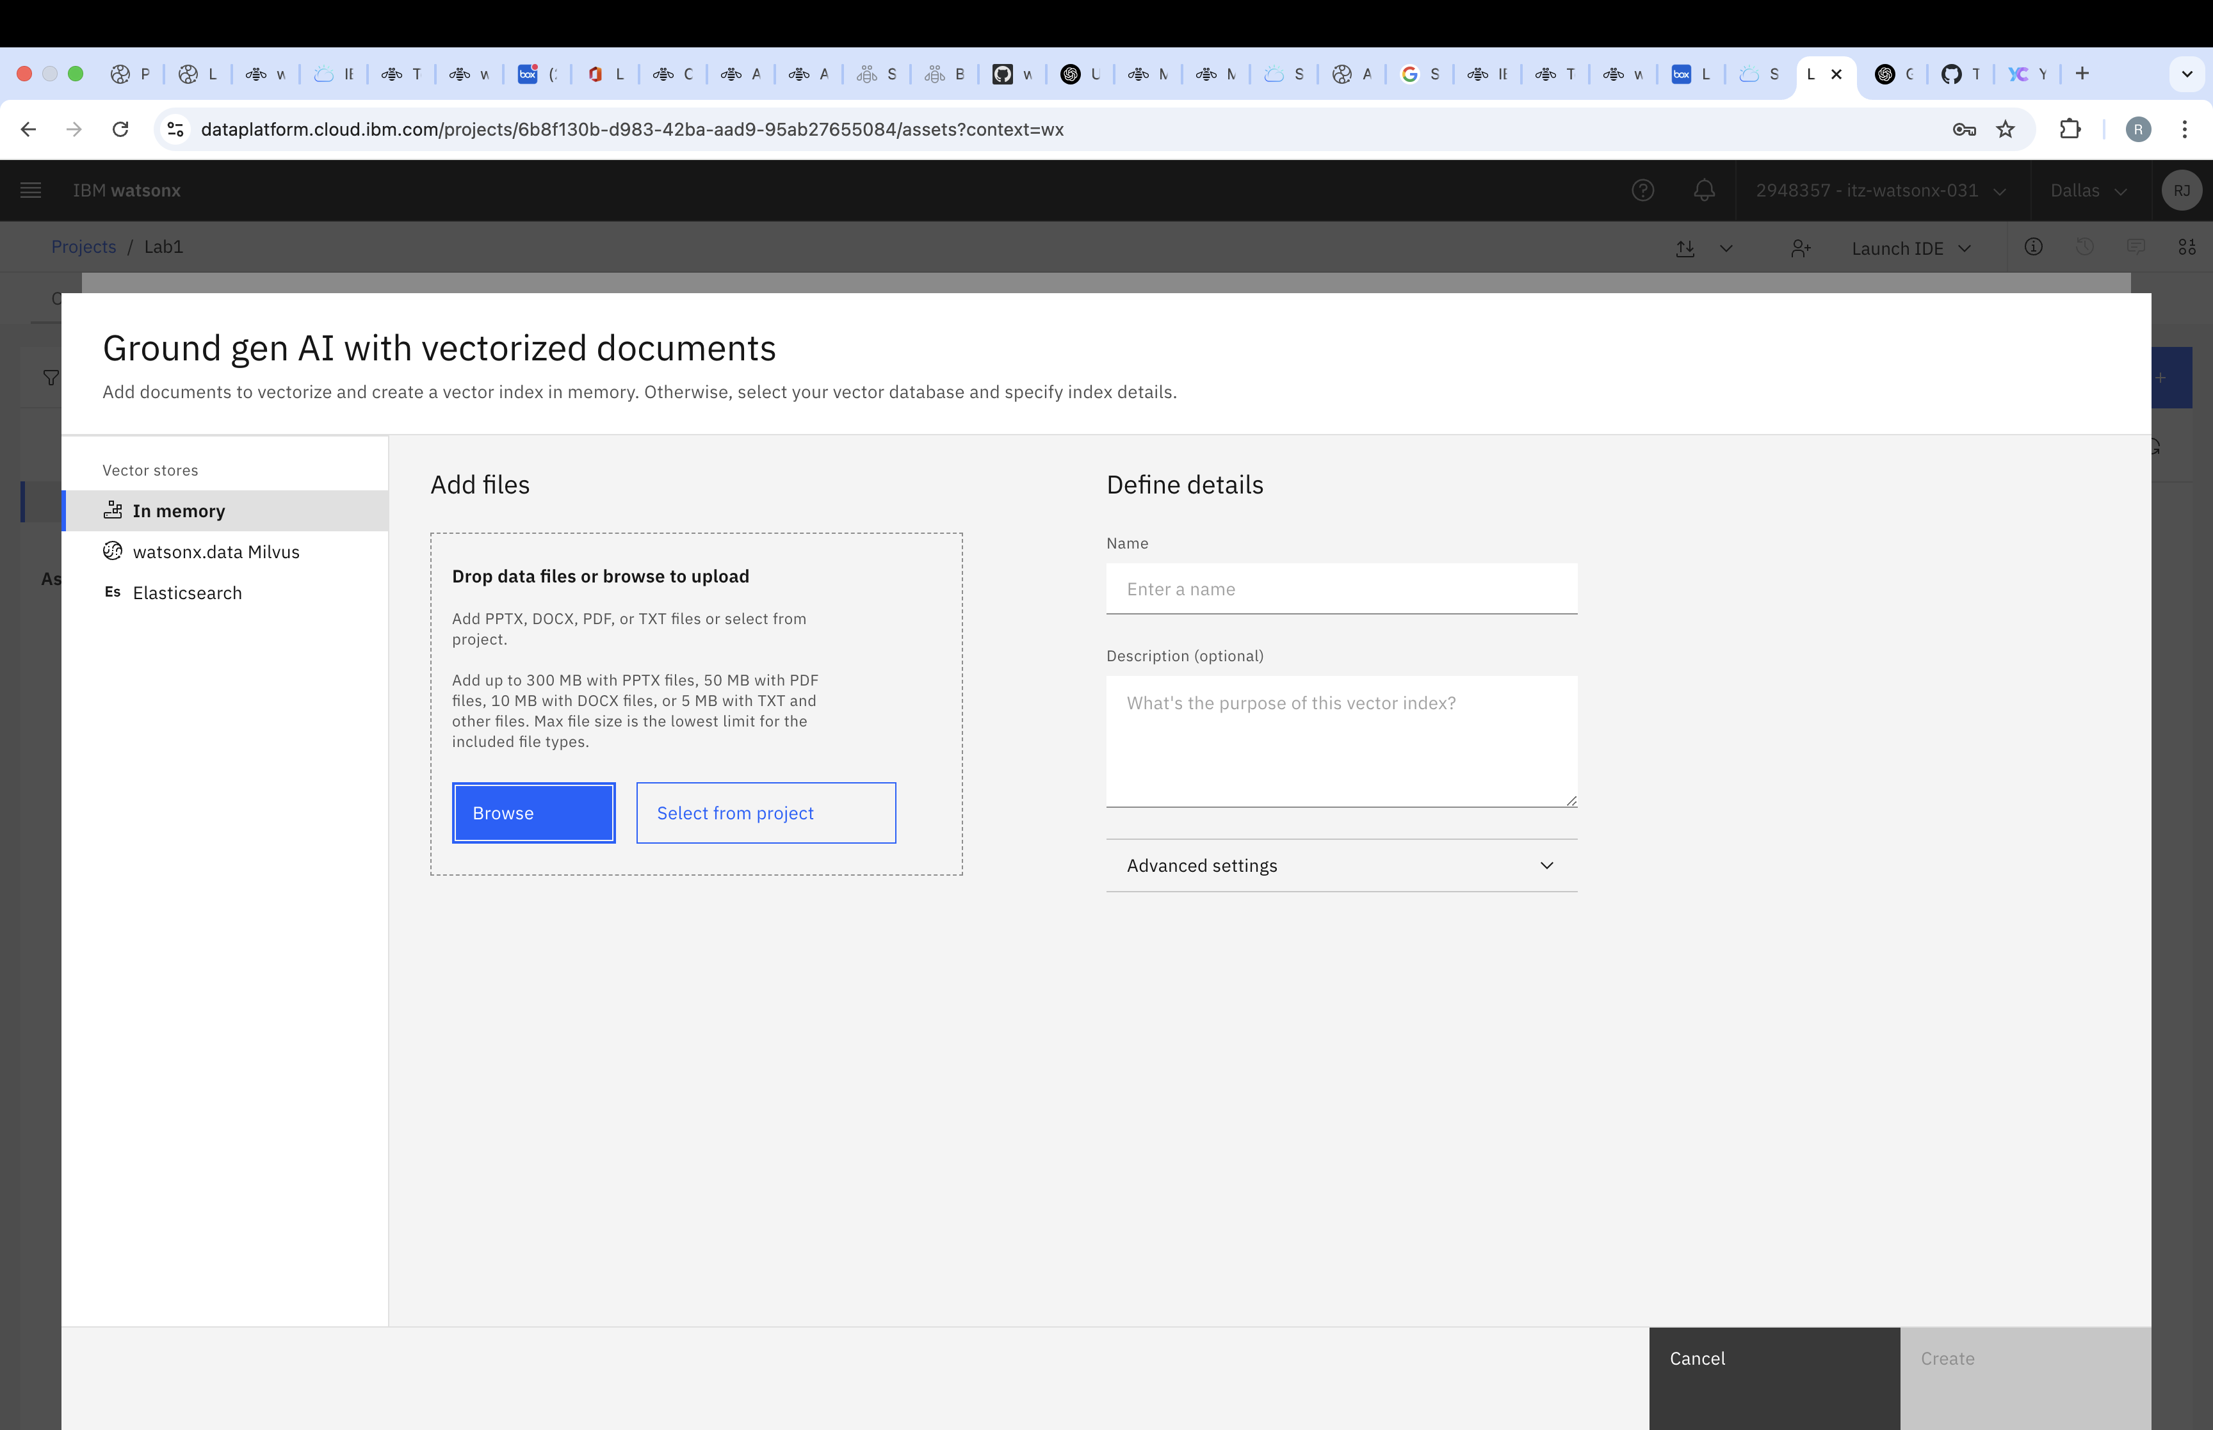

Step 6: Upload Documents and Configure Indexing
- Upload input documents for vector index creation using the Browse option.
- Assign a name to your vector index.
- Click on Advanced Settings to configure the following:
  - Embeddings Model (multilingual-e5-large)
  - Indexing Parameters such as Text Chunk Size and Text Chunk Overlap.
- Click Create to generate the vector index.

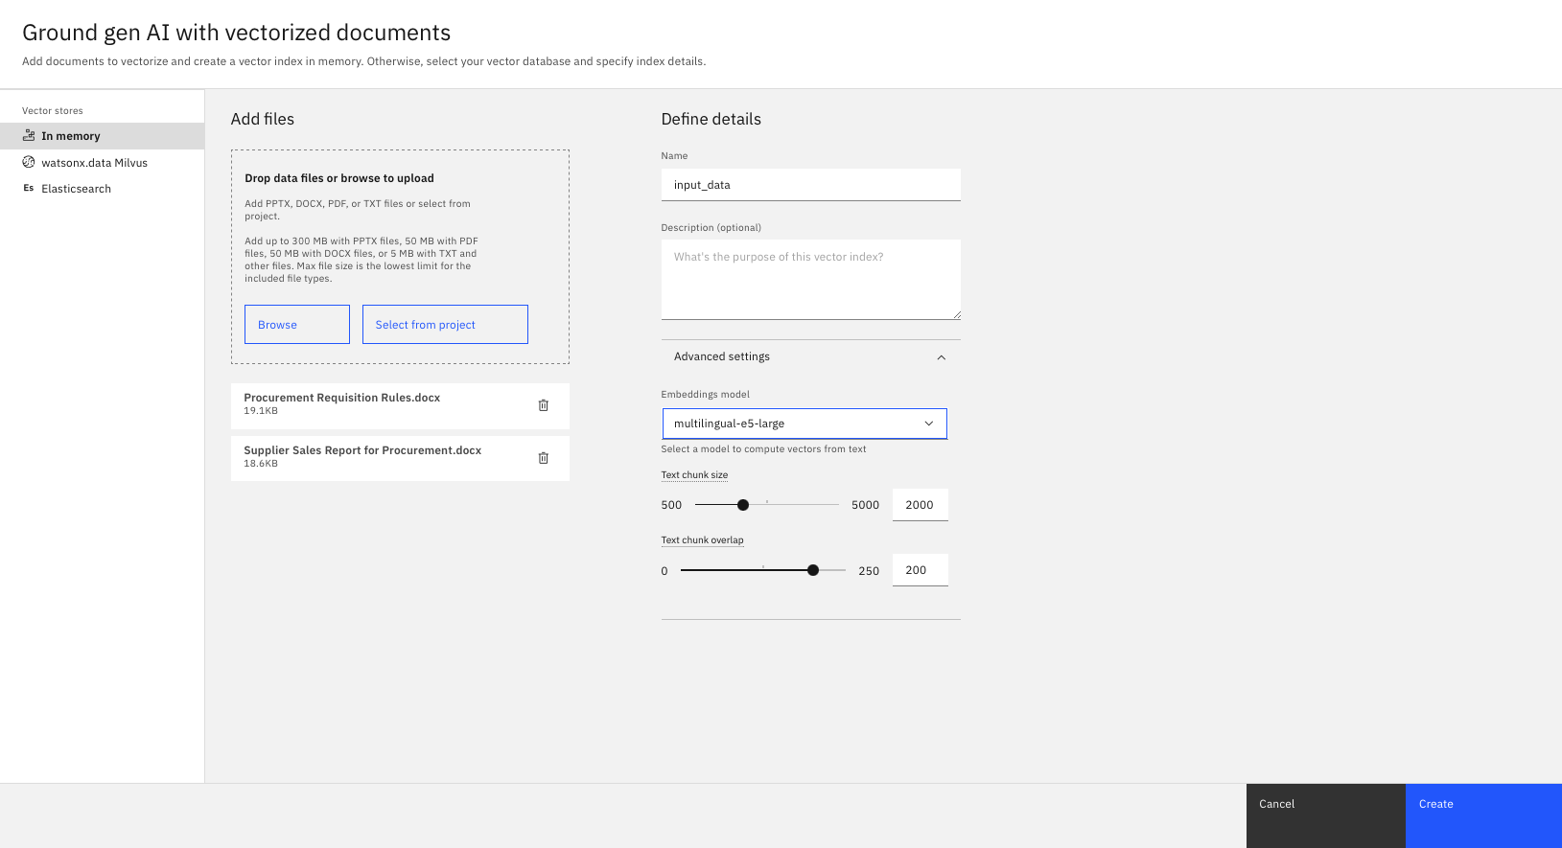

Step 7: View Vector Index Details
- Once the index is created, a summary screen will display all configured details.

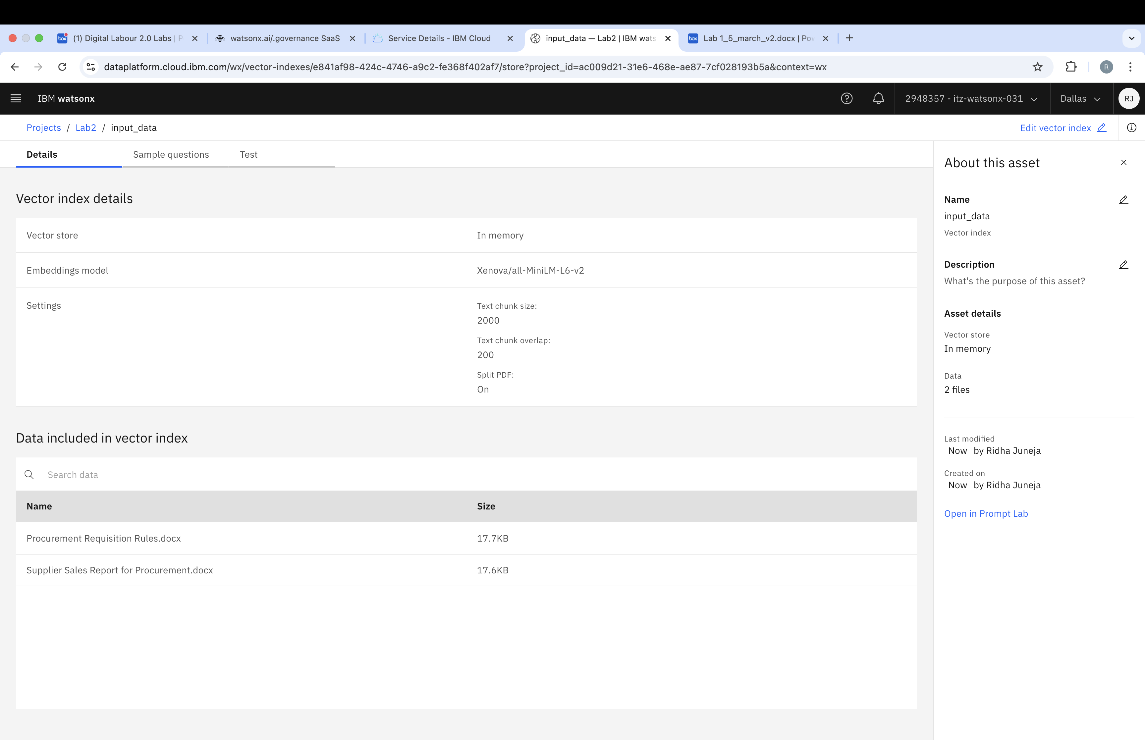

Step 8: Create an AI Agent
- Click on New Asset and search for "Build an AI Agent to Automate Tasks".

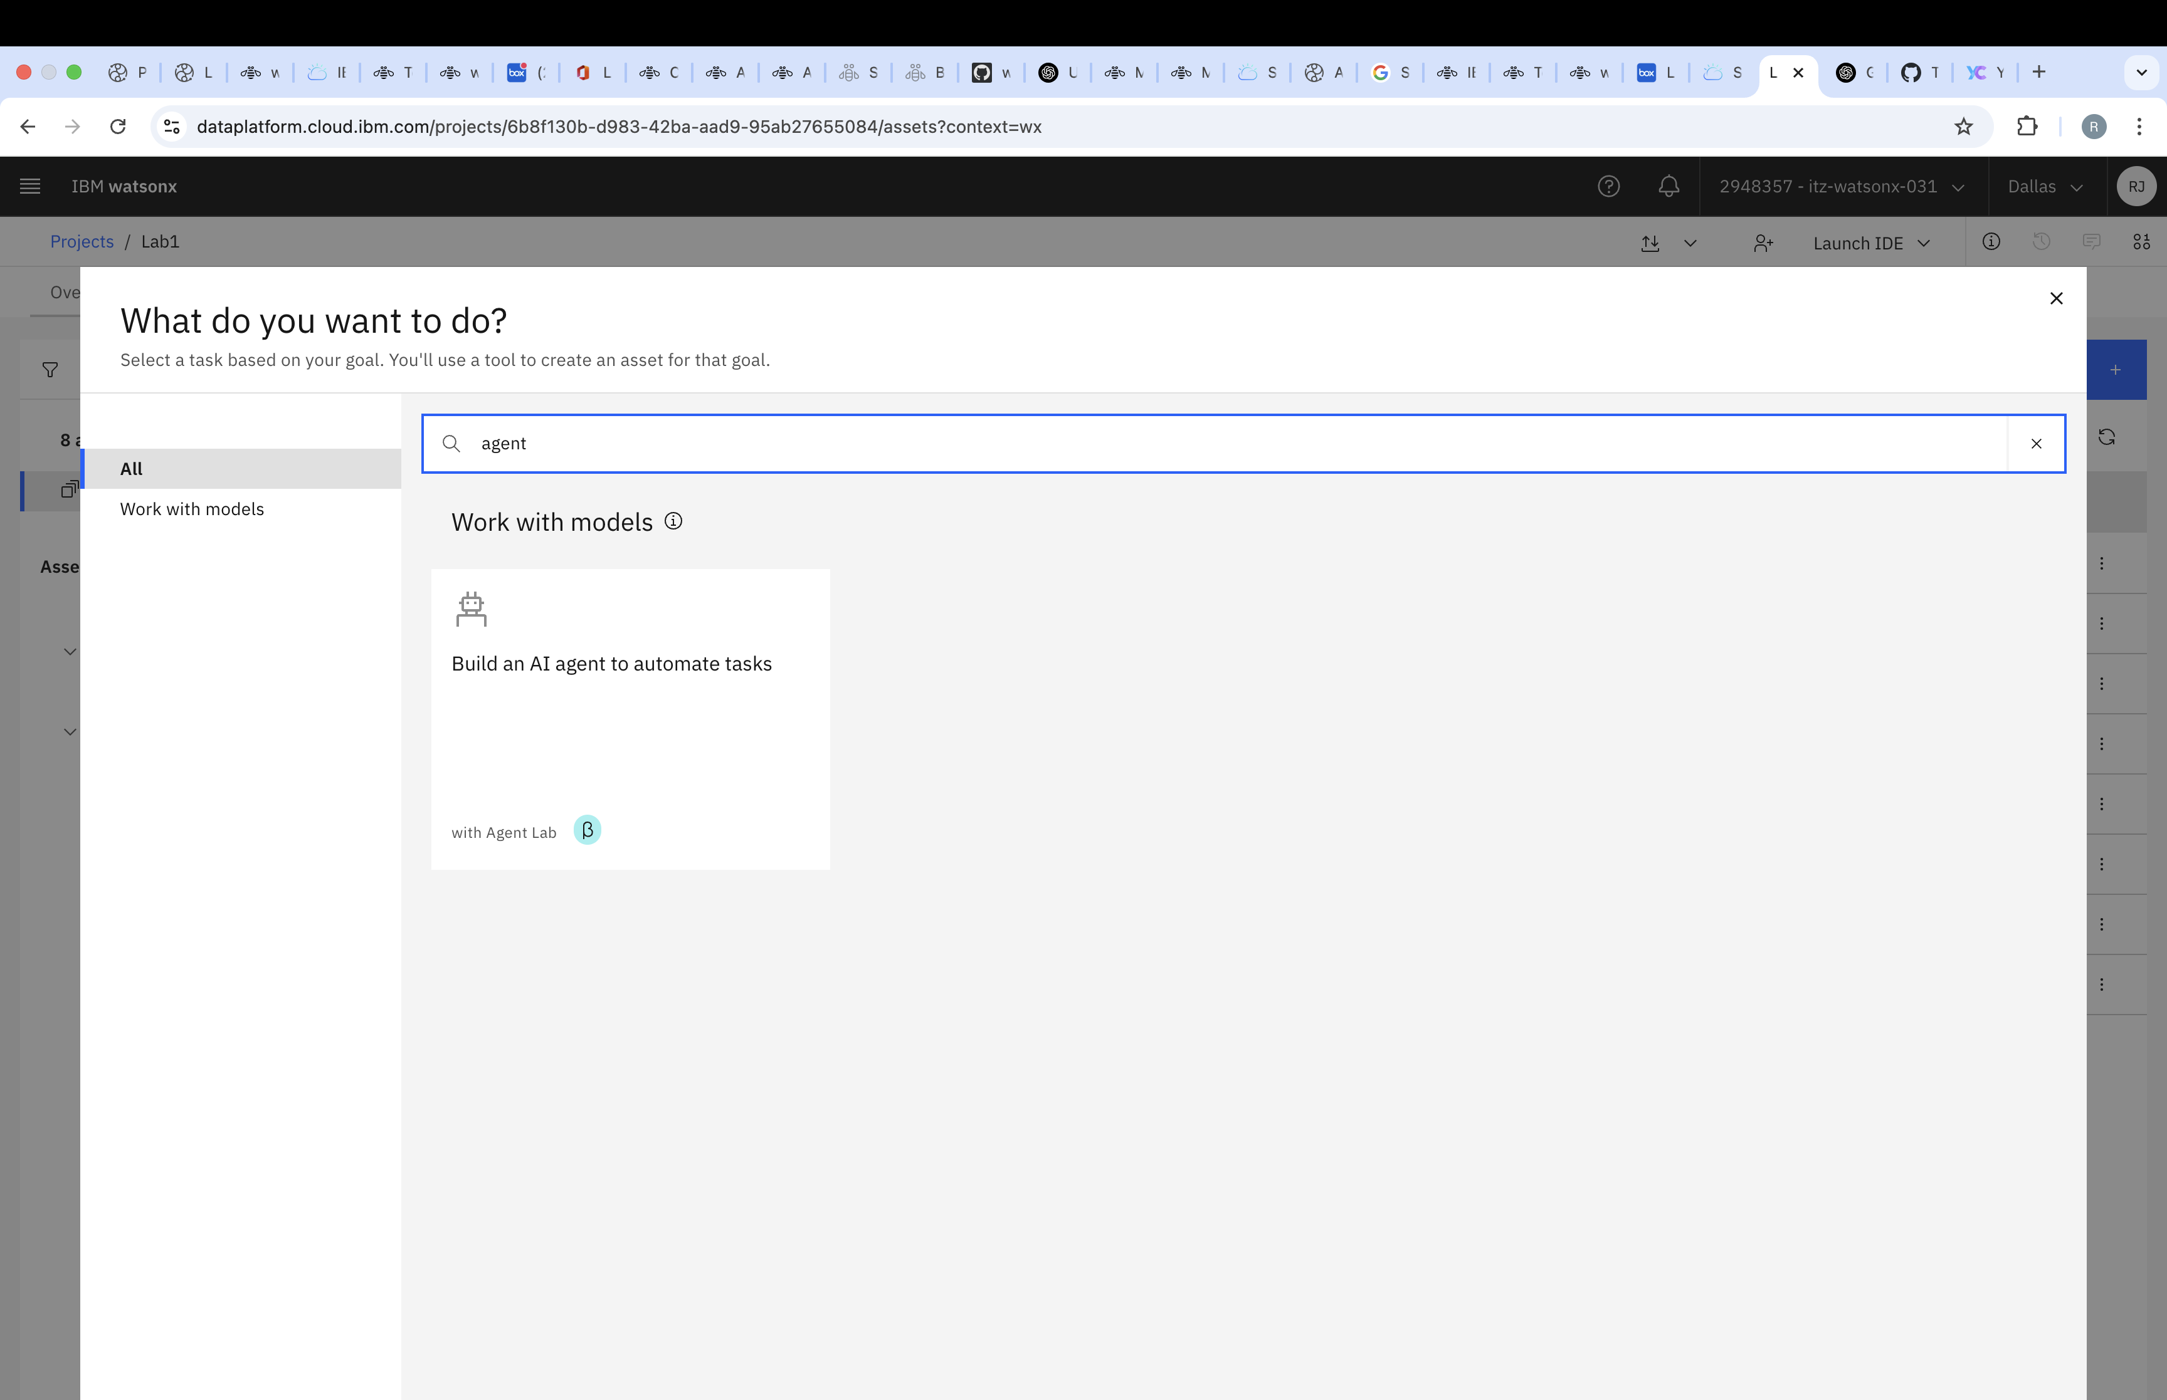

Step 9: Name Your AI Agent
- Click Build an AI Agent to Automate Tasks and assign a name to your agent.

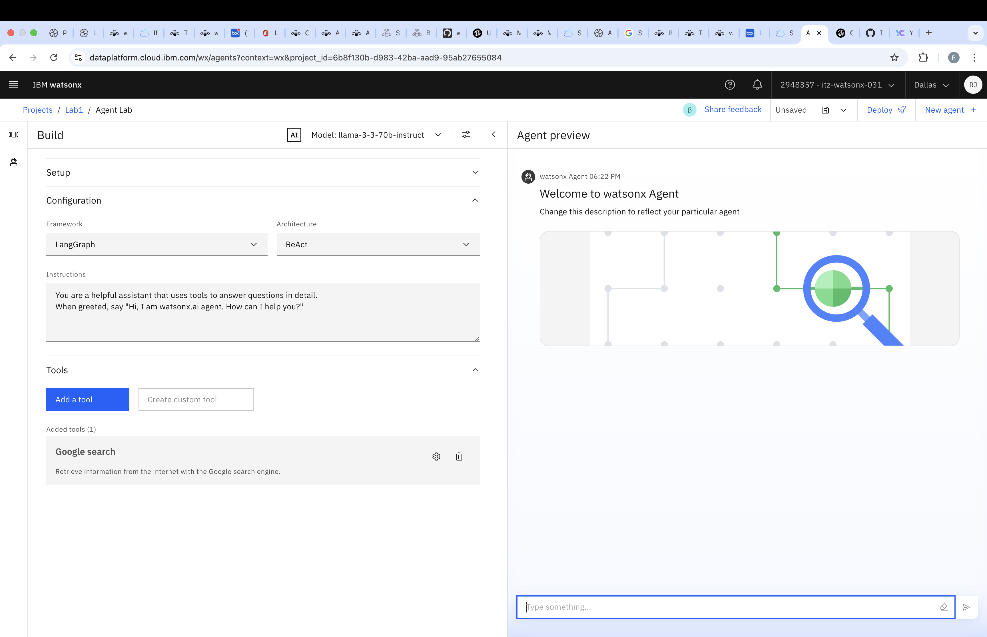

Step 10: Add Tools to the Agent
- Click on Add Tool to open a selection panel.

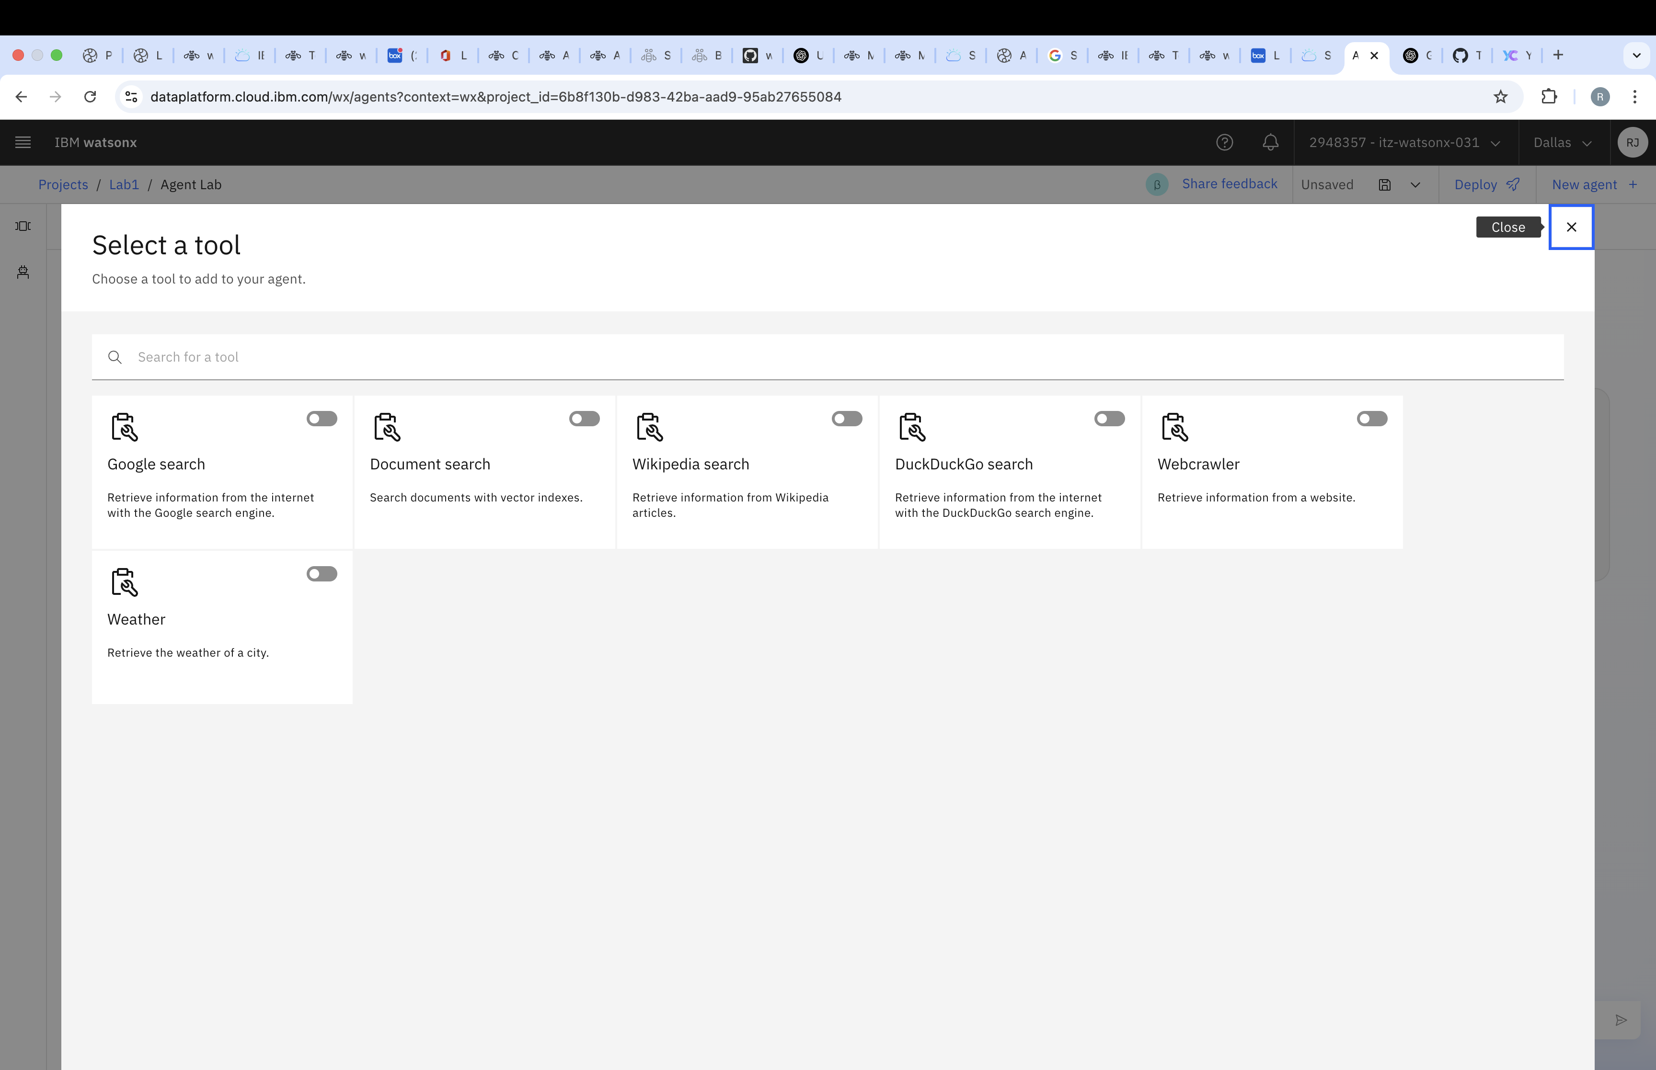

Step 11: Link the Vector Index
- Toggle Document Search to enable it.
- In the dropdown menu, select the vector index you created earlier.
- Click Select to confirm.

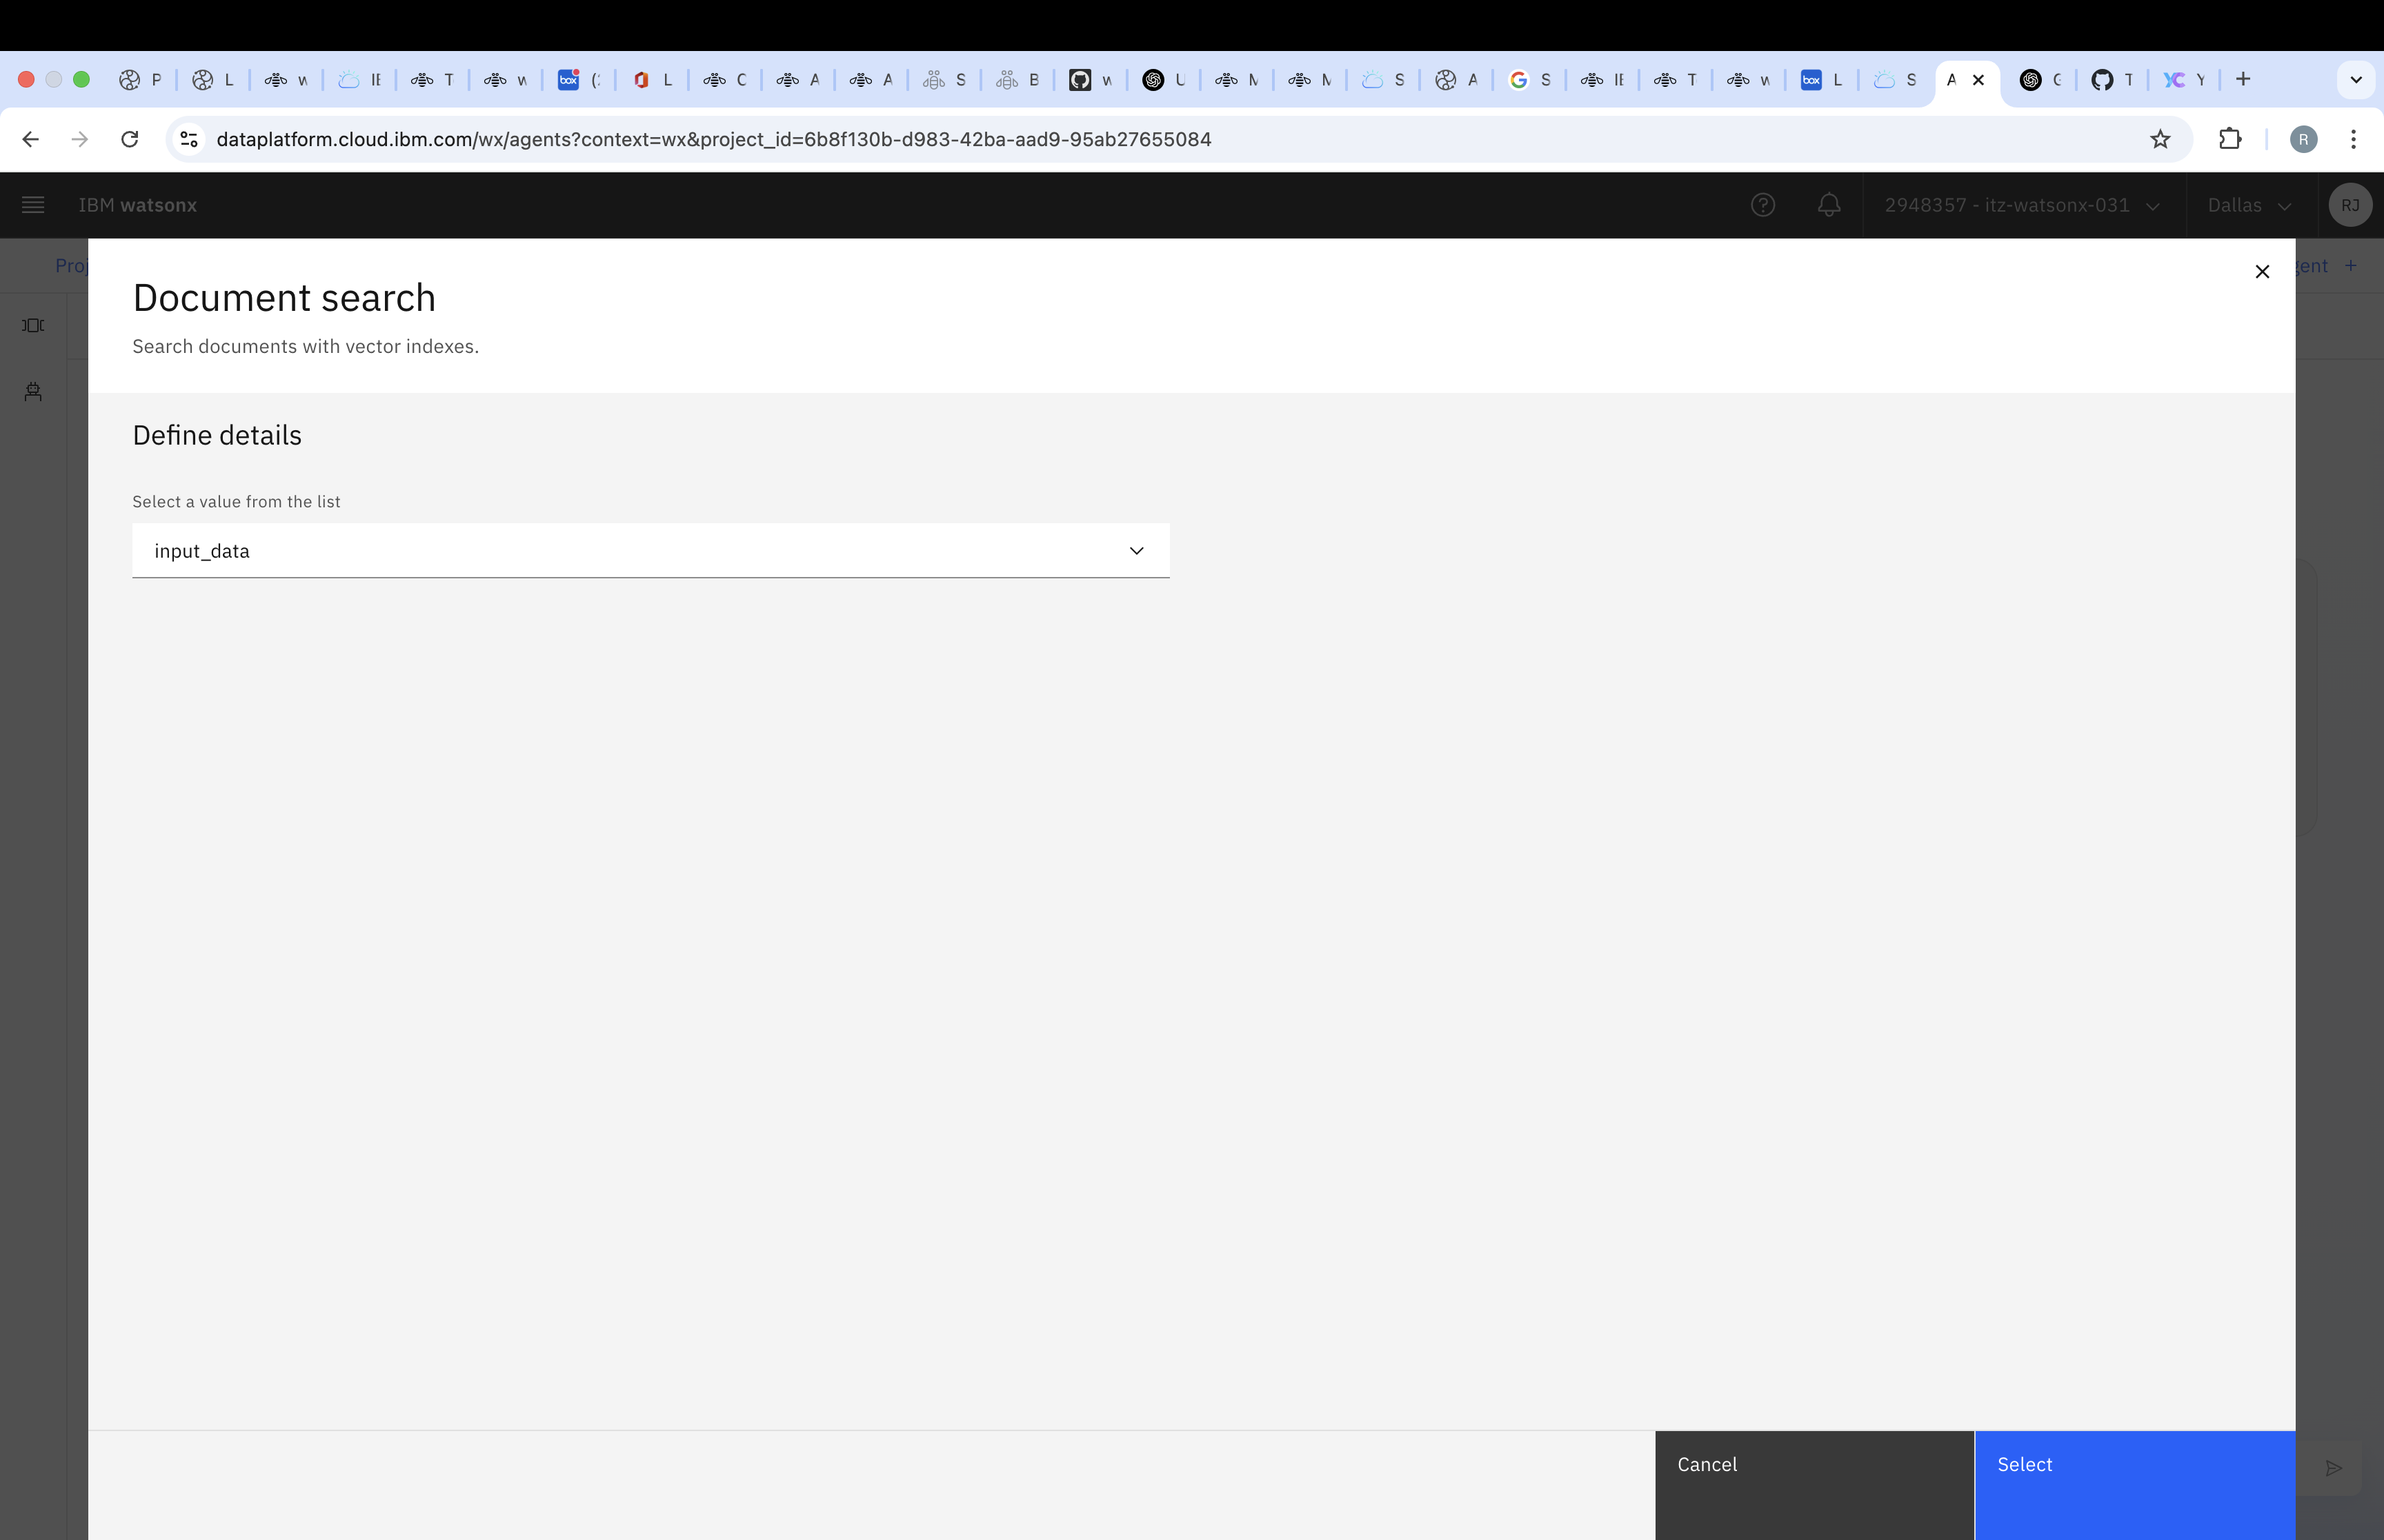
Step 12: Add Additional Tools
- Enable the Google Search Tool as an additional tool for your agent.
- The tool panel will now display both Document Search and Google Search Tool.

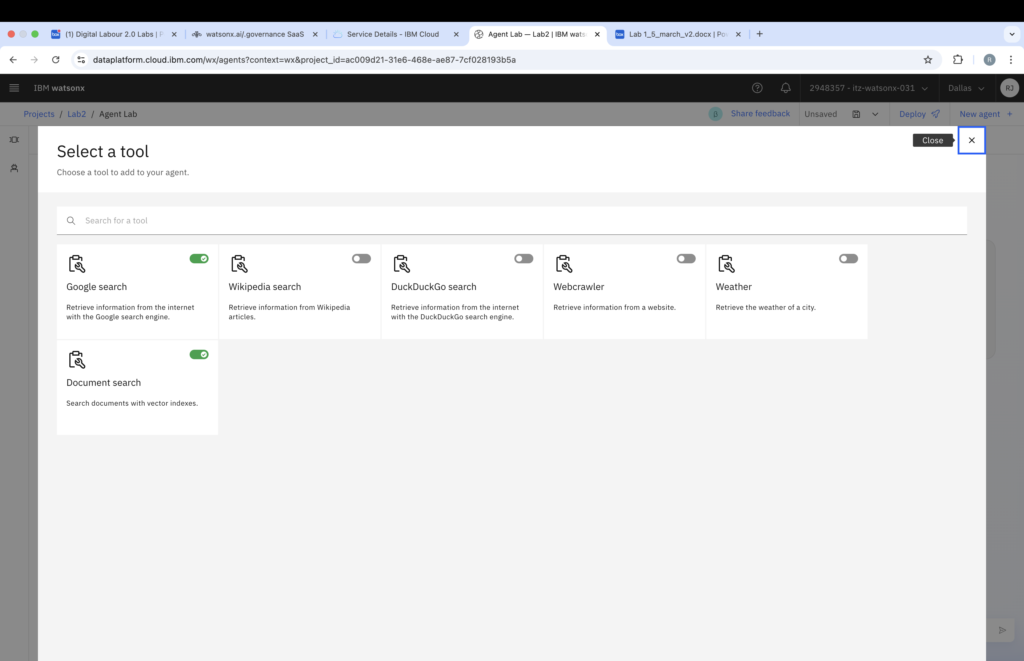

Step 13: Configure the Agent Model and Parameters
- Adjust the foundational model, prompt and other configuration parameters as needed.
Prompt:
You are a helpful assistant that uses tools to answer questions in detail.
When greeted, say "สวัสดีครับเป็นยังไงบ้างผมคือ watsonx.ai"

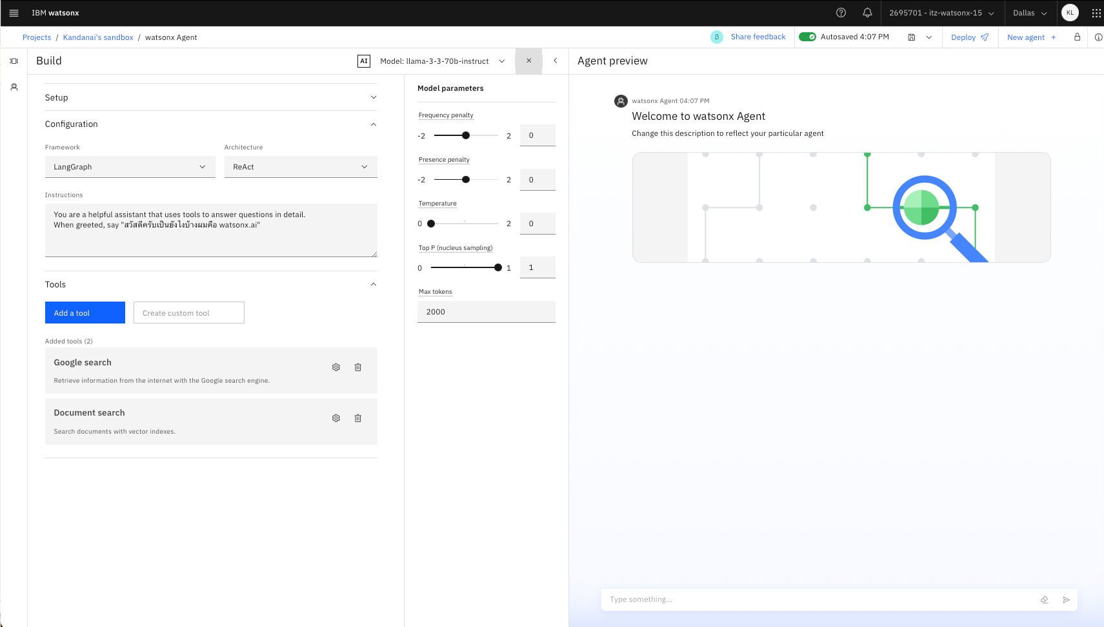

Step 14: Test Your AI Agent
- Start querying your agent with example questions, such as:
  - Supplier ไหน Excelentia Supplies หรือ Global Office Supplies ช่วยบอกข้อดีและข้อเสียของแต่ละ supplier ให้หน่อย
  - supplier ไหนส่งของไว
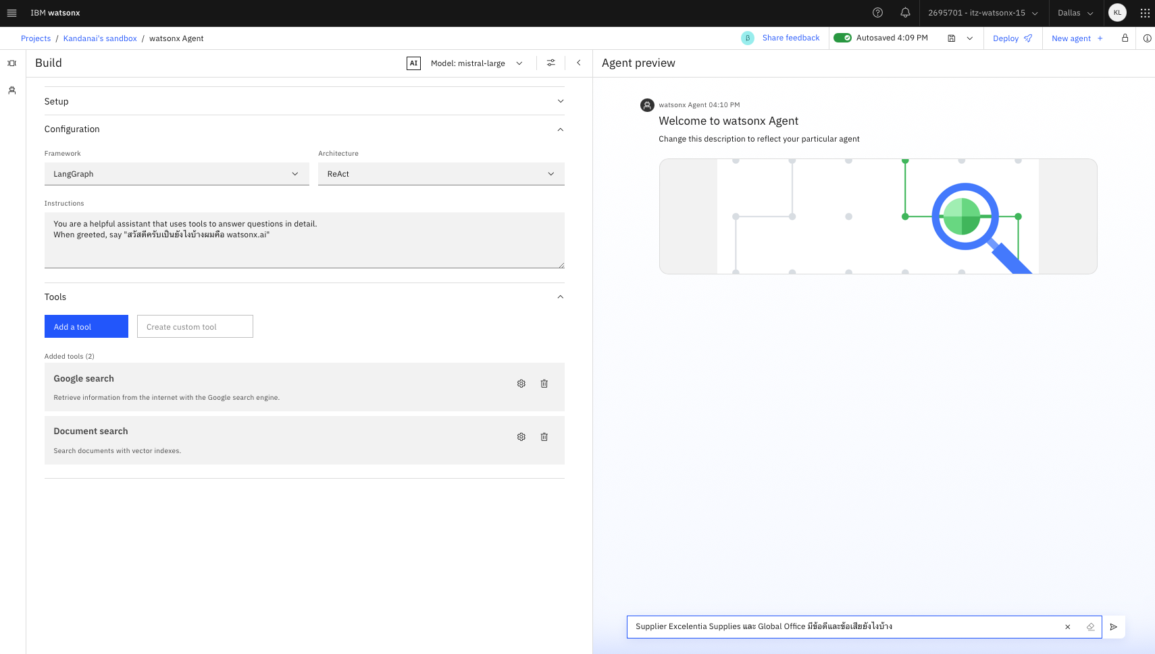

Step 15: View the Agent's Response
- The AI agent will generate a response based on the indexed data.

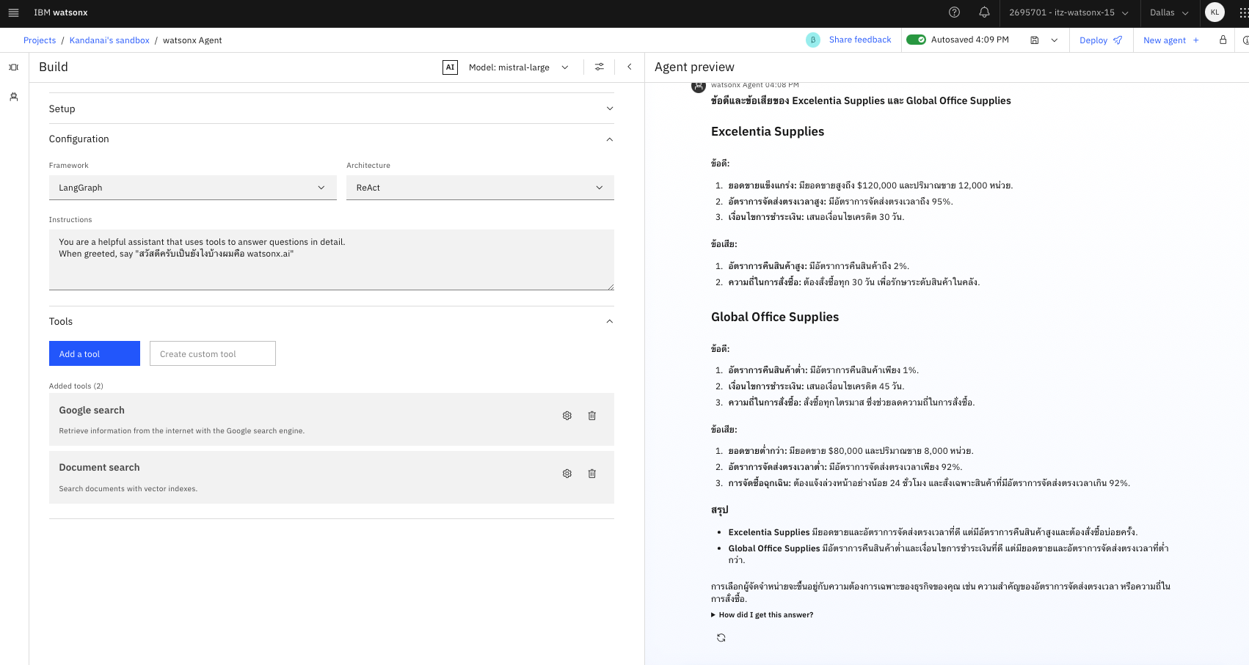

Step 16: Save Your Agent
- Click Save As to store your agent configuration.

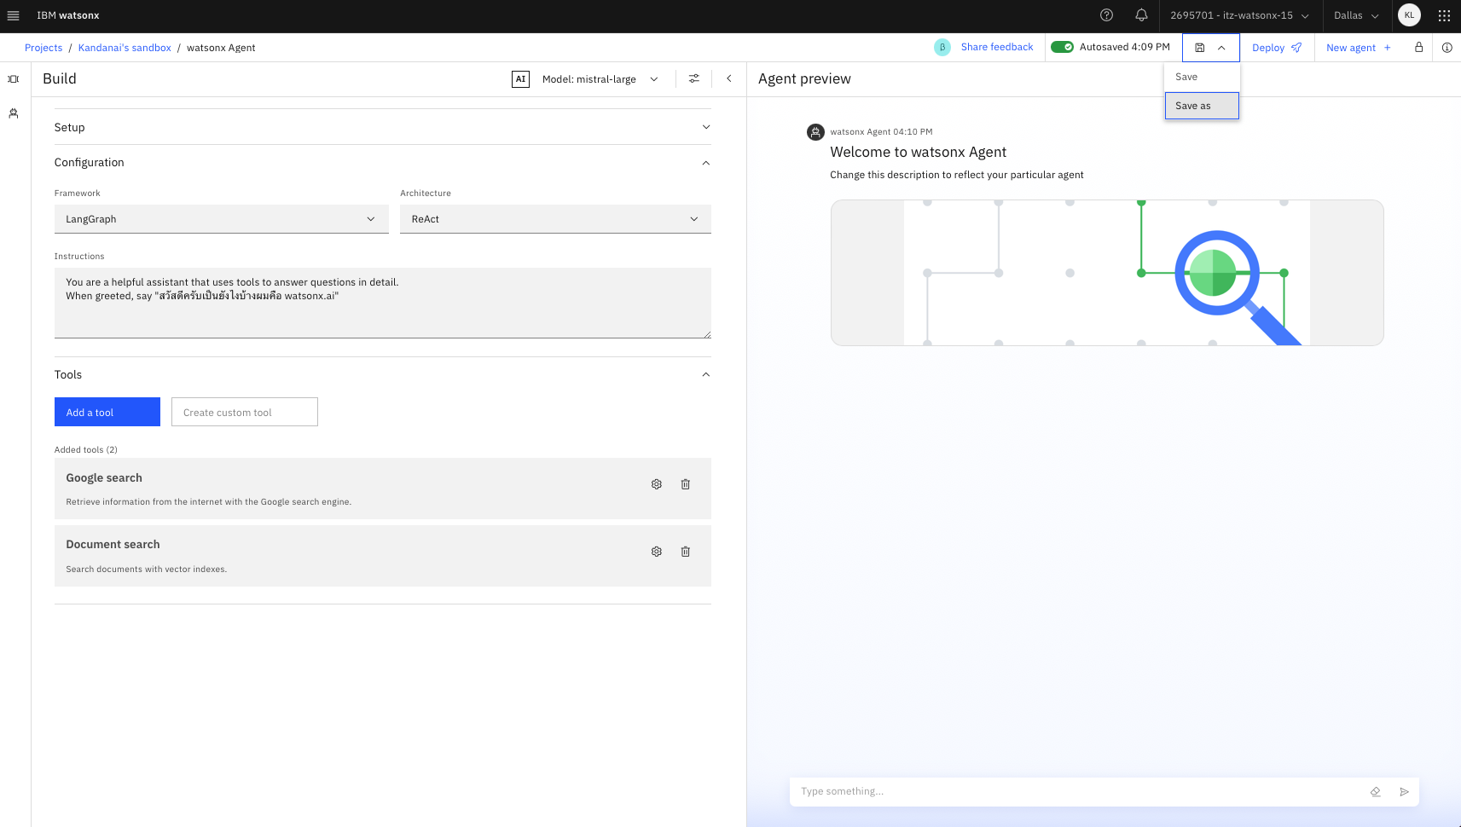

Step 17: Export the Agent
- Save your agent as a notebook or an editable file for future modifications.
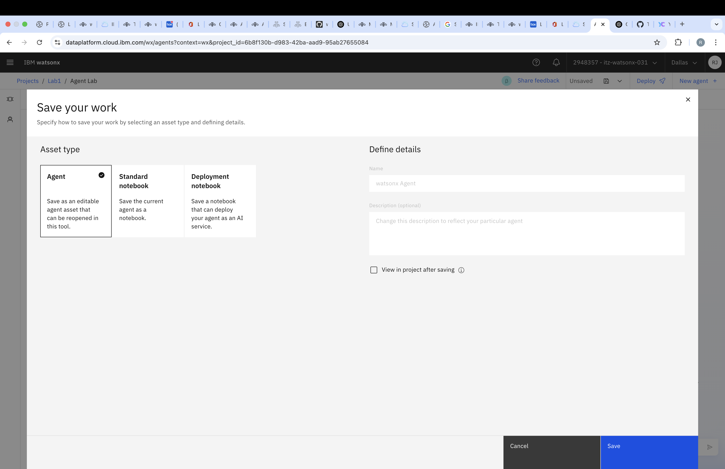

🚀 Congratulations! You have successfully created an AI-powered Supplier Research Agent. Happy Coding! 🎯

